# Setting up Application Environment

**Create Sendgrid Account**

|  |  |
| --- | --- |
| Team ID | B2-2M4E |
| Project Name | Skill/Job Recommender Application |

**Step 1.** Navigate to https://sendgrid.com

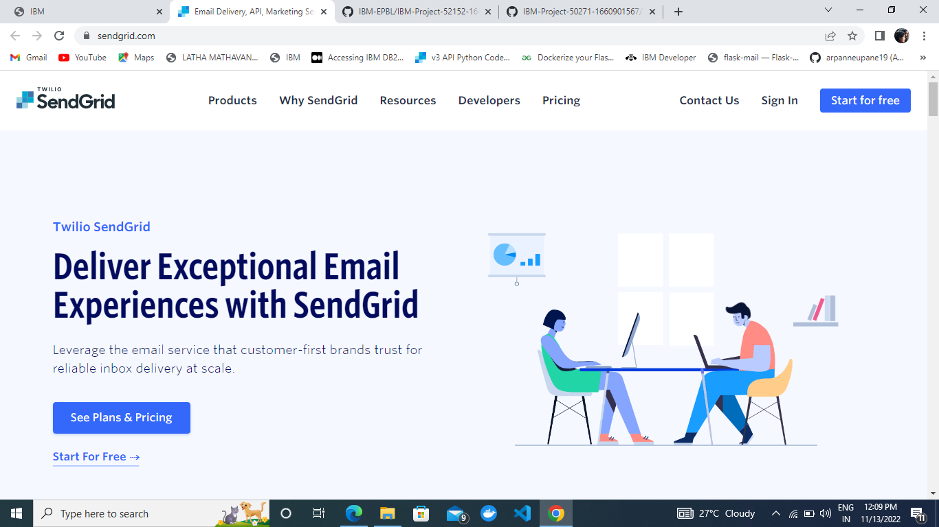

s

**Step 2.** Click on “Start for free” and register yourselves by entering required details and click on create account

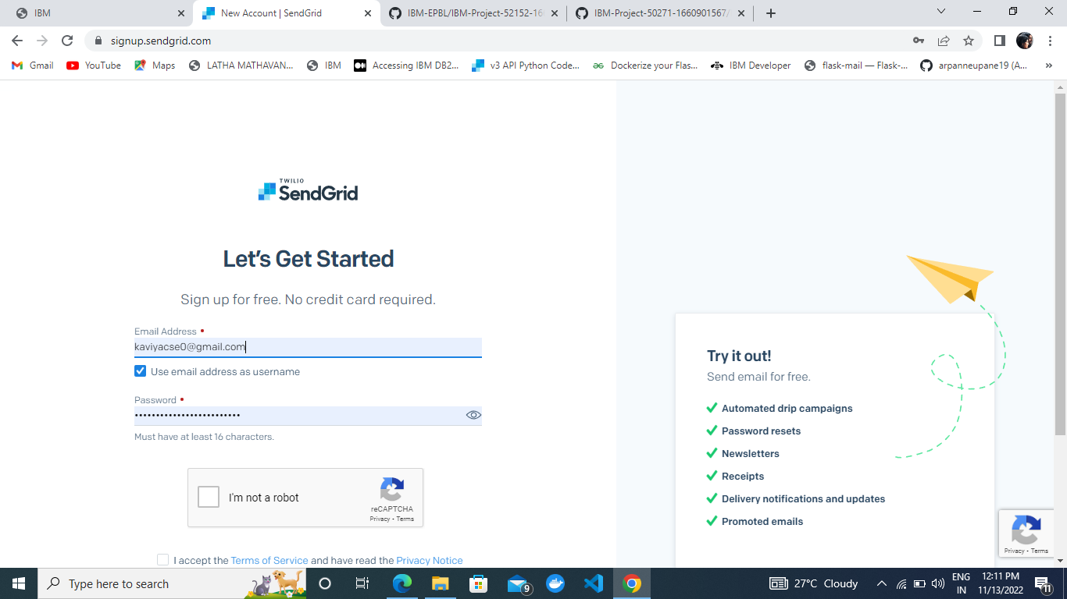

# Output:

Send Grid account created successfully